**Assignment 3**

**Pankaja Balasooriya**

**SKF2400104**

**Task 1 – Dataset**

Motion: UP DOWN

Waveform:

When device is moved up and down it is moved mainly along the z axis. So by examining the waveforms we can see that there is a significant variation of the waveform of the accZ (along z axis) while accX and accY show insignificant variation. When device is moved up or down along the z axis its acceleration increases in that direction comes to its maximum and accelerates in the opposite direction. This variation is depicted in the accZ waveform.

Motion: Snake

Waveform:

When device is moved in snake motion, there is no significant movement f the device along z axis. This is also visible in the waveform of accZ as it shows a very small to no significant change in the waveform. In the snake motion device mainly moves along the Y axis of the device. This can be verified by the changes shown in the accY waveform. Also, there is some motion along the X axis so we can see that also in the waveform. Even though is not significant as Y axis there is some little motion along X axis during snake motion of the device.

Loaded Dataset on Edge Impulse:

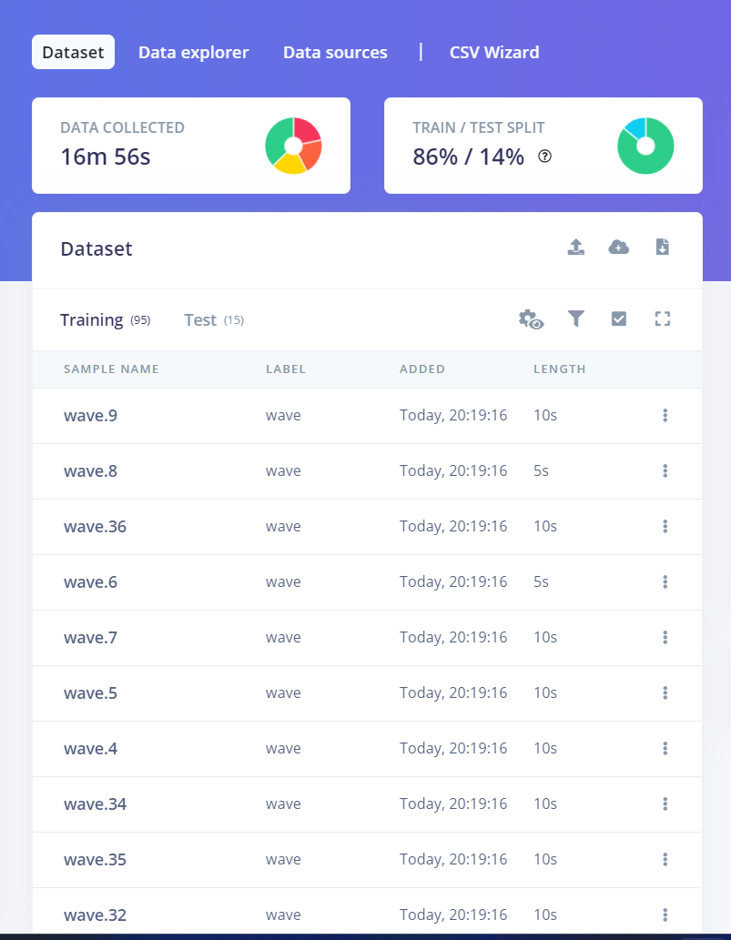

**Task 2 – Creating an impulse**

Impulse created

**Task 3 – Feature extraction**

Selected parameters

**Task 4 – Model training and testing**

Neural Network settings and architecture

Training performance

Results for Test Dataset

Reasoning for selected parameters.

Different values for each of the parameters were tested and loss was compared against each other. Then ideal values given above were selected to avoid over fitting and significant accuracy.

**Task 5 – Deployment**

The model was deployed in Arduino Nano 33 BLE sense and following motions were performed.

Idle:

Snake:

Updown:

Wave:

